I’m Loving It?
Mixed by Kelley Blakewood
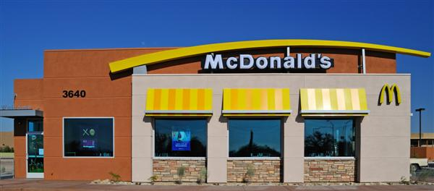

Every morning on my way to work I drive past McDonalds, and every morning I can’t help but ask myself… is it really possible? Is it possible that the days of Ronald McDonald, happy meals, and gigantic golden arches are really over?
The McDonalds Company began raising eyebrows in 2003 when executives decided it best to drop their traditional kid-centric image in order to target an older more mature market. Six years and billions of dollars later, they have actually begun to achieve what most deemed impossible: change their brand image. To compete with coffee houses and café type restaurants, McDonalds has revamped both its menu and store layouts. McDonald’s restaurants now offer a variety of coffees, ranging from iced chocolate mochas to espressos. Additionally, most McDonalds’ include coffee bar tables, metal barstools, and free wireless internet access. CEO Charlie Bell says, “these changes are meant to offer consumers a better overall brand experience.”
I’m certainly going to miss the iconic child friendly McDonalds, but I’m pretty excited to see what the new McDonalds has to offer. Maybe one of these mornings, I'll stop to enjoy a cup of coffee and actually be able to say, I'm lovin it.
Source: EmeraldManagementFirst, Re-Branding, the Mcdonalds Stategy, Emerald Group Publishing Limited

